EDA and Insights Report

Objective
This report explores cost, discount, and return behavior to identify key drivers of revenue and profitability.
The goal is to surface patterns, anomalies, and risk areas that inform business decision-making.

Dataset Context
Analysis is performed at the order-item level on ~75.9k records from January 2023 to December 2024.

KPI Snapshot

Total Revenue (excluding returns) | $441912053.28
Total Profit (excluding returns) | $227258031.41
Return Rate | 8.9%
Loss Making Order Rate | 44.51%
Revenue exposed to low/negative margin ( excluding returns) | 13.24%

Core Explorations

Insight 1: Overall margin has plateaued between 42–45% with no upward trend.
Observation: Monthly overall margin fluctuates within a narrow band of 42–45% across the entire time period.
Evidence:
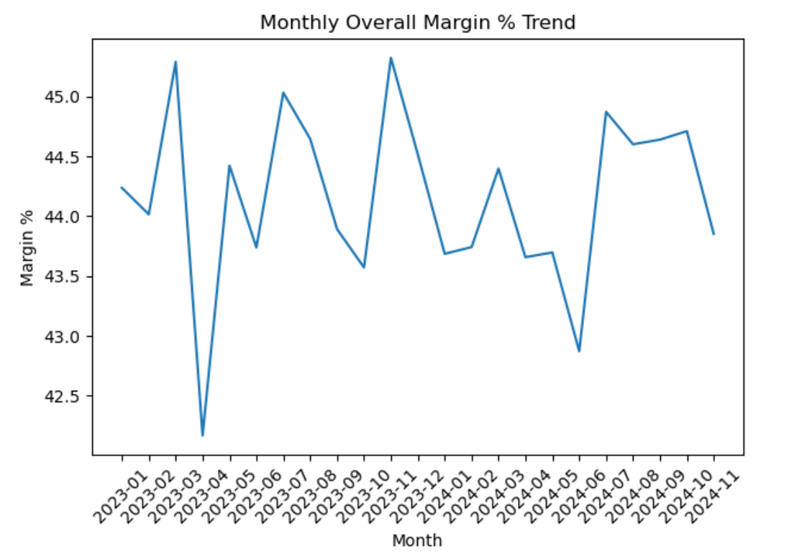

Why it matters : Despite stable revenue, margin stagnation indicates that profitability is not improving over time, suggesting limited pricing or cost efficiency.

Insight 2 - Loss concentration varies significantly by product category
Observation: Beauty and Home categories show high loss frequency and weak margins, while Electronics maintains stable profitability and Fashion shows moderate but manageable risk.

Evidence:
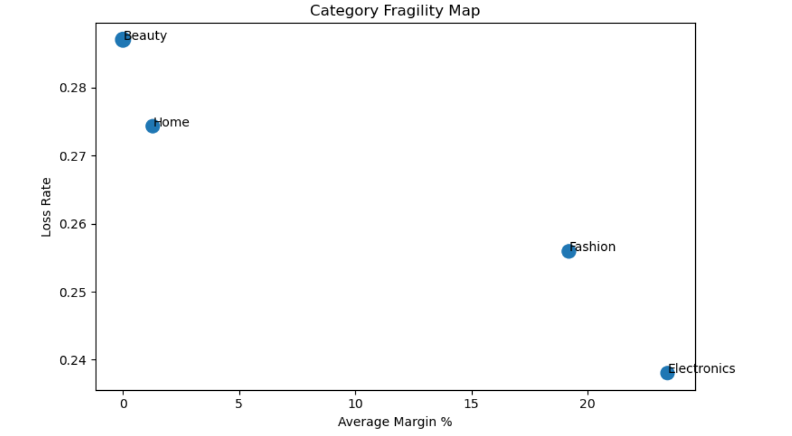

Why it matters: Category-level risk is uneven. Investment and expansion should prioritize Electronics and Fashion, while Beauty and Home require margin correction strategies.

Insight 3 - A structural 30% of orders Operate at low margins
Observation: Approximately 30% of total orders consistently fall into the low-margin segment

Evidence:
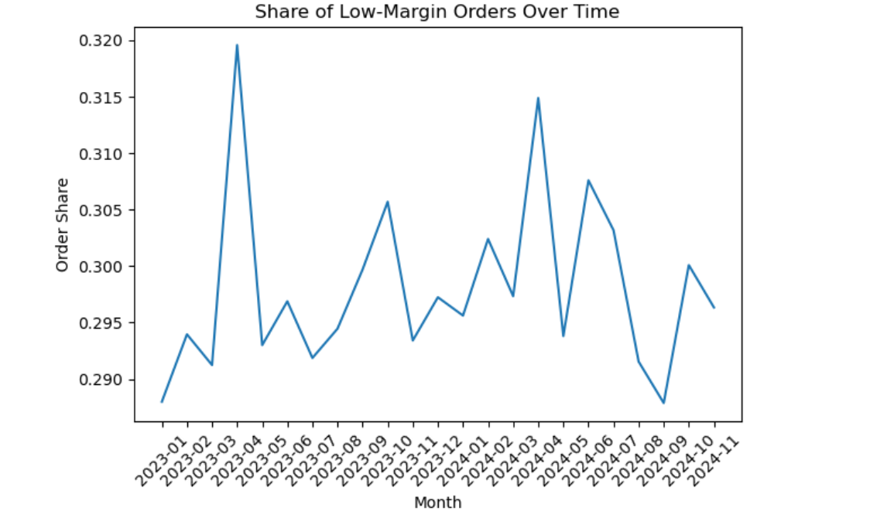

Why it matters : This is not a temporary issue. A large portion of revenue is generated by orders that contribute disproportionately little profit, creating persistent margin pressure.

Insight 4 - Pricing and cost issues are the dominant source of losses
Observation: Pricing and cost-related drivers account for approximately $33M in total losses, far exceeding other loss drivers.

Evidence :
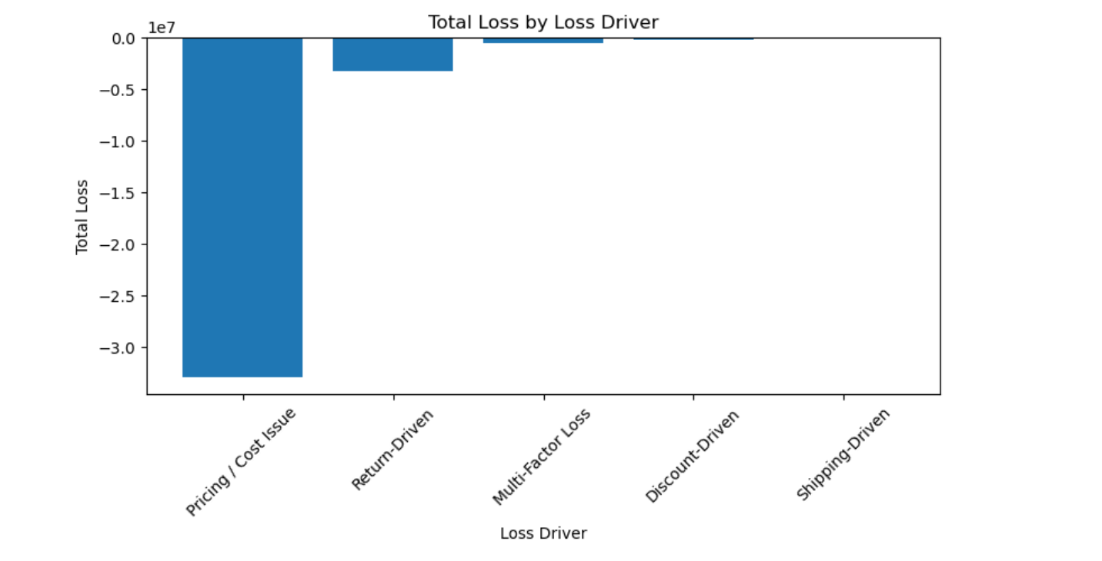

Why it matters: Profitability improvement efforts should focus primarily on pricing discipline and cost control, as this area represents the largest recoverable loss pool.

Insight 5 - Discounts have a strong negative relationship with margin
Observation: Average margin declines steadily as discount levels increase, indicating a negative correlation between discounting and profitability.

Evidence:
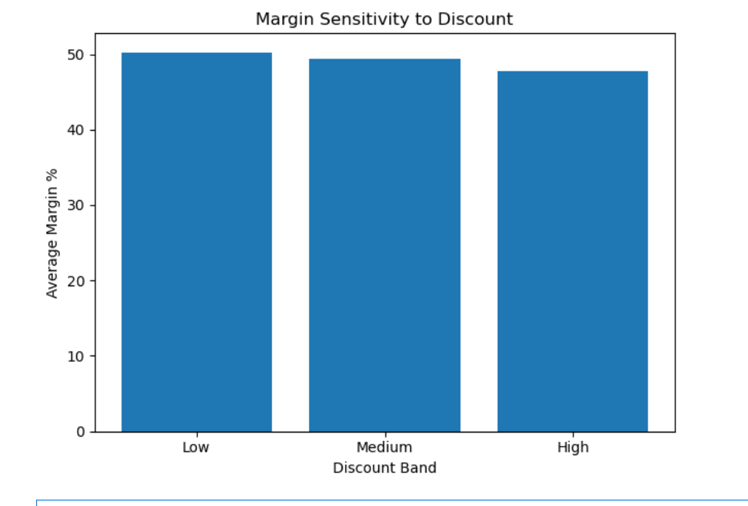

Why it matters: High-discount orders generate revenue volume but erode profitability, suggesting the business is trading margin for sales without sufficient return.

Insights Summary

- Overall margin trend is stuck between 42 – 44 percent.
- Discount intensity is a primary driver of margin erosion.
- Fashion and Electronics are good category for investment decisions.
- Discount intensity is a primary driver of margin erosion.
- $33 Million dollar loss due to Pricing / cost issue.

